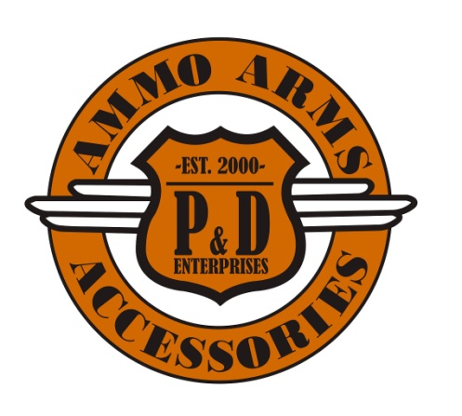
P&D Enterprises
10552 115 Street NW
Edmonton, AB T5H 3K6
Phone: 780-420-6419
Fax: 780-420-1945
Email: info@pdent.ca

Item(s) Ordered:

Part(s) Number:
Billing/Shipping Address *If Billing and Shipping Address are different, we cannot at this time, accept Credit Card as Payment Method. Please Use EMT*

Land Location
(if different from above):
Full Name:
Phone Number:
Email:
PAL / RPAL License Number:
PAL / RPAL License Expiry:
Date of Birth:
Credit Card Number (Visa or Master Card):
Card Expiry:
3-Digit Security Code:
For EMT Transfer Only (Send to info@pdent.ca)
All EMT’s will auto deposit.
Place of birth:
(For restricted firearm)
Range membership:
(Restricted firearm only) Please provide name of range membership:
P&D ENTERPRISES POLICY
Special Order Policy:(Not in Stock Items) **Special Order Items Are Non-Returnable**
A non-refundable, non-transferable deposit of 20% is required. Balance is due in full once the product arrives. Cancellation of these terms will result in loss of all deposits. All delivery times and pricing are subject to change and are only estimations.
Layaway Policy:(In Stock Items)
A non-refundable, non-transferable deposit of 20% is required. Balance is due in full within 60 days of layaway date on all in stock items. If this is a consignment item, it must be paid in full within 30 days. If items are not paid in full within these terms all deposits will be lost.
Condition of Sale:
All Guns Are Final Sale-all manufacturers’ defects on new guns must be dealt with thru the distributor at owners’ expense.
By returning/filling in this form you are agreeing to these policies

